# 1️⃣ User & Group Management

### **Task:**

### **Create a user devops_user and add them to a group devops_team.**

* To create the user in linux the command used is **sudo useradd -M devops_user**
* The users present in the system can be seen in the **/etc/passwd file**

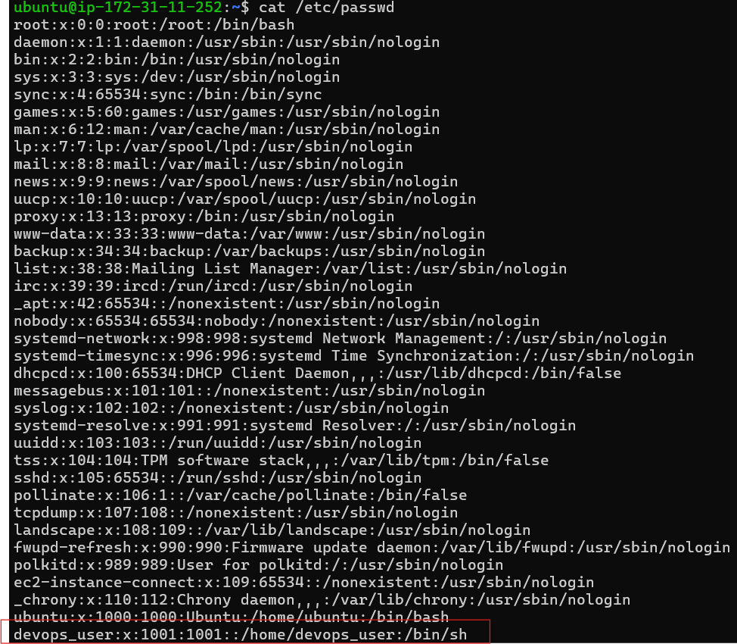

* The list of the groups are present in /etc/group

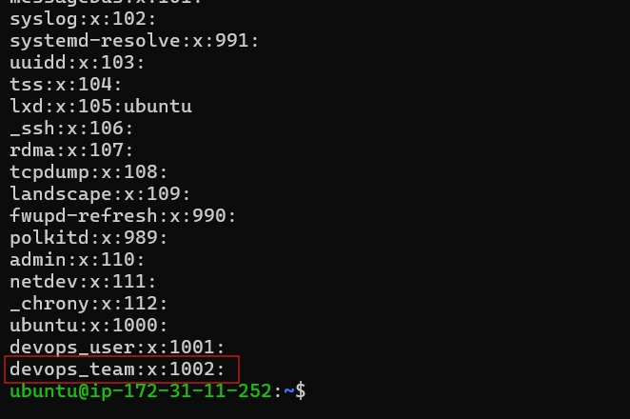

* Now we need to add the devops_user to the group devops_team
* In order to do this we have a command : **sudo gpasswd -a devops_user devops_team**

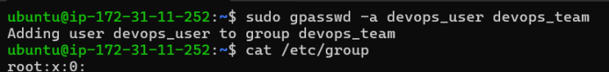

**Set a password and grant sudo access.**

* In order to set the password and grant the user devops_user sudo access we need to add the user to the sudo group.
* This can be done using the command: **sudo usermod -aG sudo devops_user**

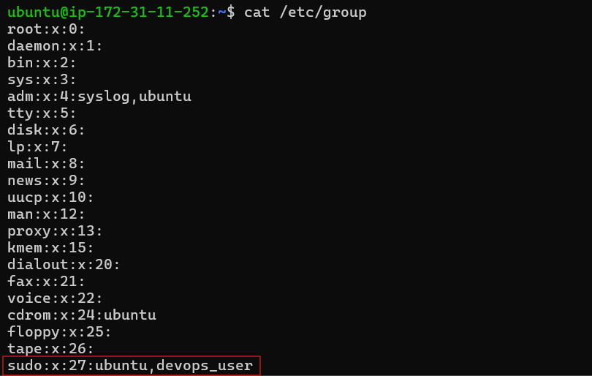

This shows that the user devops_user has been granted sudo permission

Restrict SSH login for certain users in /etc/ssh/sshd_config.

* To deny the ssh login to the user we need to append DenyUsers <theusername> to the file  **/etc/ssh/sshd_config**
* Adding the DenyUser devops_user command to the file

